Purpose of WPF
WPF was created to solve limitations of WinForms and provide a more powerful UI system.
Its goals include:
1. Rich User Interfaces
WPF supports:
- Animations
- Gradients
- Transparency
- 2D/3D graphics
- Vector rendering

WPF Architecture Overview
Application
↓
PresentationFramework
↓
PresentationCore
↓
milcore.dll
↓
DirectX
↓
Windows

Presentation Framework
This is the top-level WPF framework layer.
Provides UI controls like:
- Button
- TextBox
- ListBox
- Grid
- TreeView
- DataGrid
Supports:
- Binding
- ObservableCollection
- Validation
- CollectionView

Presentationcore
This is the core graphics subsystem of WPF.
Contains:
- Visual
- UIElement
- DrawingVisual

Milicore.dll
Media Integration Layer Core
Direct hardware access
High performance
GPU acceleration
Converts WPF visuals into DirectX drawing commands.

WPF Has Two Main Threads
UI Thread
Handles:
- Input
- Events
- Application logic
Render Thread
Handled internally by milcore.
Responsible for:
- Rendering visuals
- Talking to DirectX

DirectX Layer
WPF ultimately renders using:
DirectX

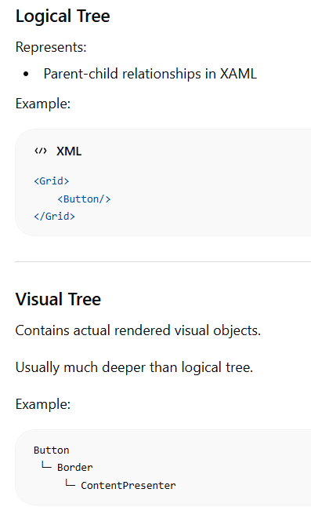
Data binding
Connecting a UI element property
to a data source property.
<TextBox Text="{Binding UserName}" />

DataContext
DataContext = person;
Now all child controls can access:
person.Name
person.Age
person.City
without specifying object references repeatedly.

Oneway binding -> used for labels
Twoway binding -> If user edits textbox: Object updates automatically.

ObservableCollection
Normal List does not notify UI.
ObservableCollection<T>
because it automatically updates UI when:
- Items added
- Removed
- Changed

MVVM flow
User types in TextBox
↓
Binding updates ViewModel
↓
ViewModel updates Model
↓
UI refreshes automatically

Dependencyproperty
DependencyProperties enable advanced WPF features like data binding, styling, animation, default values, property inheritance, and efficient memory management that normal CLR properties cannot provide.

WPF templates
  - Control templates
A ControlTemplate changes the entire visual appearance of a control without changing its functionality.
With ControlTemplate, you can make it:
Rounded , Animated , Card-like , Circular , Modern-looking

  - DataTemplate
how data objects are displayed

  - ItemsPanelTemplate
how collection items are arranged/layoutedUse ItemsPanelTemplate when:
Building photo gallery
Creating tile layouts
Optimizing large lists
Making custom layouts

Resources –
Common resources include:
- Styles
- Brushes
- Colors
- Templates
- ControlTemplates
- DataTemplates
- Animations
- Strings
- Images

Why Attached Properties Exist
Parent containers often need layout information from children.
Example:
- Grid needs row/column info
- Canvas needs coordinates
- DockPanel needs docking info

